ZH,
REPORT OF JOINT INVESTIGATION VISIT (JIV) BY NOSDRA, RIVERS STATE MINISTRY OF ENVIRONMENT, NAOC AND COMMUNITY MEMBERS ON 18’’EOC-OGODA PIPE LINE AT EGBEE AHOADA WEST LGA, RIVERS STATE.
Please find below highlights of JIV to the above location.
- COMPANY ADDRESS: NIGERIAN AGIP OIL COMPANY LIMITED, EASTERN DIVISION, P.O.BOX 923, PORT HARCOURT, NIGERIA. TELEX: +2349096372000.
- LOCATION/SITE ADDRESS: 18’’EOC –OGODA PIPE LINE AT EGBEE,AHOADA WEST LGA, RIVERS STATE.
- GEOREFERENCE COORDINATES/INCIDENT NUMBER:
- N 05⁰ 08’ 05.4” E 006⁰ 34’ 26.3”/2022/LAR/185.
- DATE OF INCIDENT: 03/10/2022.
- DATE OF REPORT: 03/10/2022.
- INSPECTION DATE AND TIME: 04/10/2022. AT 14:00HRS
- INSPECTION TEAM:
- NOSDRA IDOKO JOSEPHINE O.
- RSMENV EBIANGA DAPPA
- NAOC JOHN JAPHETH
- NAOC OZZRO O .ISAAC
- COMMUNITY REP.(EGBEE) KELVIN OKPARA
- SITE CONTACTS: JOHN JAPHET (08063339471)
- PURPOSE OF INSPECTION/ INVESTIGATION: Event Response.
- COMPLIANCE HISTORY: The site complies with the Agency’s law and regulations and NAOC responded appropriately.
- IMPACTED AREA: 0.096571Ha.
- QUANTITY SPILLED: 6.1 bbl.
- OPENING CONFERENCE: After the initial welcome formalities, a tool-box/safety briefing coordinated by John Japheth was carried-out. Safety procedures required for the site work was explained to the team on ground for the job. After which the team were further intimated about the site incident.
- WALK THROUGH INSPECTION: The JIT set out to inspect the area of impact after the tool box/safety briefing. The JIT observed the following:
- The team observed that there was an attempt by unknown persons to sabotage a 18” EOC –Ogoda Pipeline at Egbee community.
- The cause of the incident was said to be third party interference.
- Impacted area was 0.096571Ha.
- Hacksaw cuts of 140mm were observed at 11-12 O’clock positions on the pipeline caused by unknown persons.
- Thus, the quantity spilled was estimated to be 6.1bbls, with no quantity recovered.
- CLOSING CONFERENCE: At the end of the inspection, stakeholders signed off the JIV documents before departure.
- COMPLIANCE CONCERN: None Observed.
- PHOTOGRAPHS: The following pictures in figs. 1 – 3 were some of the visuals and pieces of evidence captured during the JIV. Showing the incident points and the areas affected. (see pictures below).

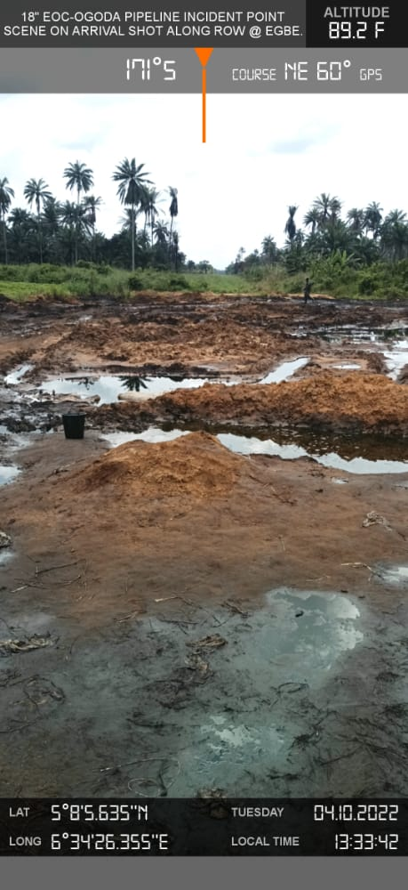
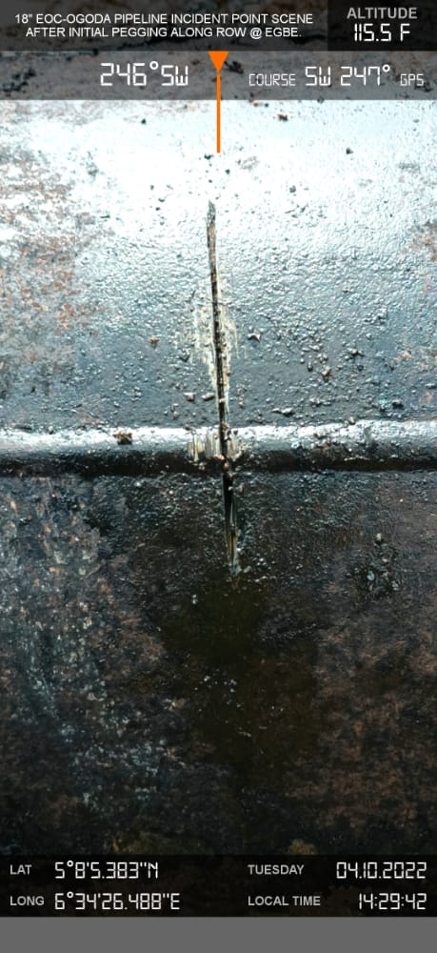

INCIDENT POINT BEFORE EXCAVATION INCIDENT POINT AFTER EXCAVATION
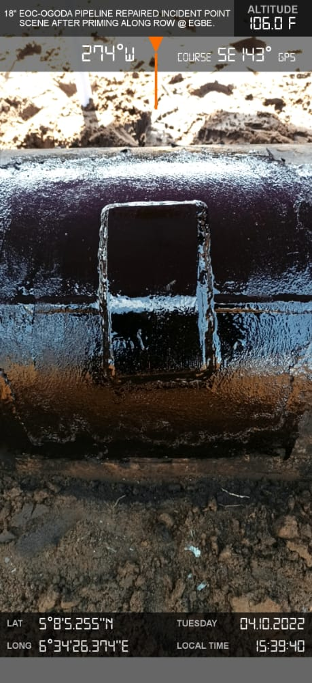

SPILL POINT AFTER REPAIR

18. RECOMMENDATION:
- Repairs should be carried-out immediately.
- NAOC should improve surveillance on the facility.
- Clean-up should be carried-out immediately.
This is submitted for your consideration and further directive, please.

IDOKO JOSEPHINE O.
SES

